Chapter 3, Problem 33.

Which of the circuits in Fig. 3.82 is planar? For the planar circuit, redraw the circuits with no crossing branches.

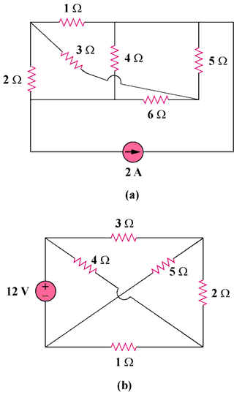

Figure 3.82
For Prob. 3.33.

